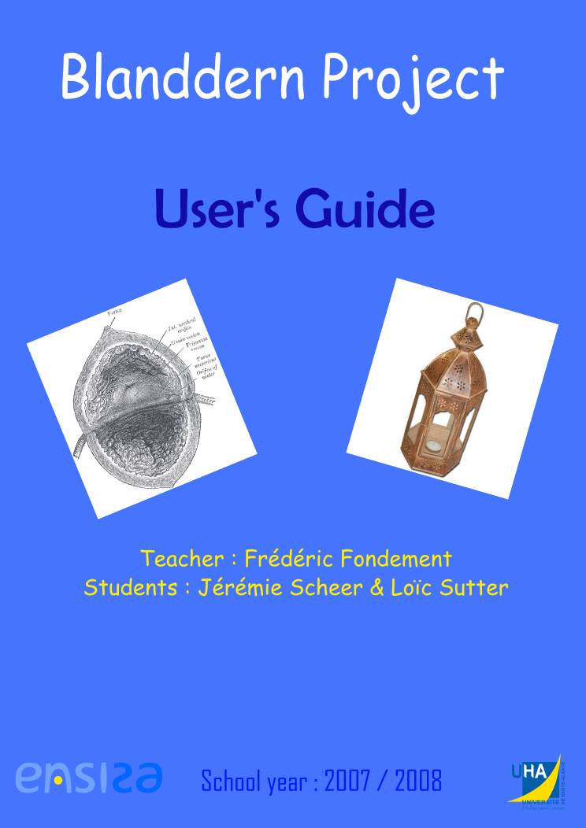

This manual is aimed to guide the user through every step of the model adaptation. Each windows and message of the program and every action that the user must complete are clearly and easily explain.
A general schema of the adaptation mechanism will allow to better understand the software key points and the necessary plug-ins for the adaptation will be described in another part. Finally, you will see all the errors that can appear while the program is being executed with their known explanations. If you aren’t used to some points of the adaptation, you can find some useful links in the documentation part.

Summary

Summary 2
I Adaptation mechanism 3
II Required configuration 4
III Necessary plug-ins 4
IV How to adapt model 5
V Bugs and errors 13
VI Documentation links 14
VII Contacts 14
Table of contents : 15
Table of illustrations : 16

I Adaptation mechanism

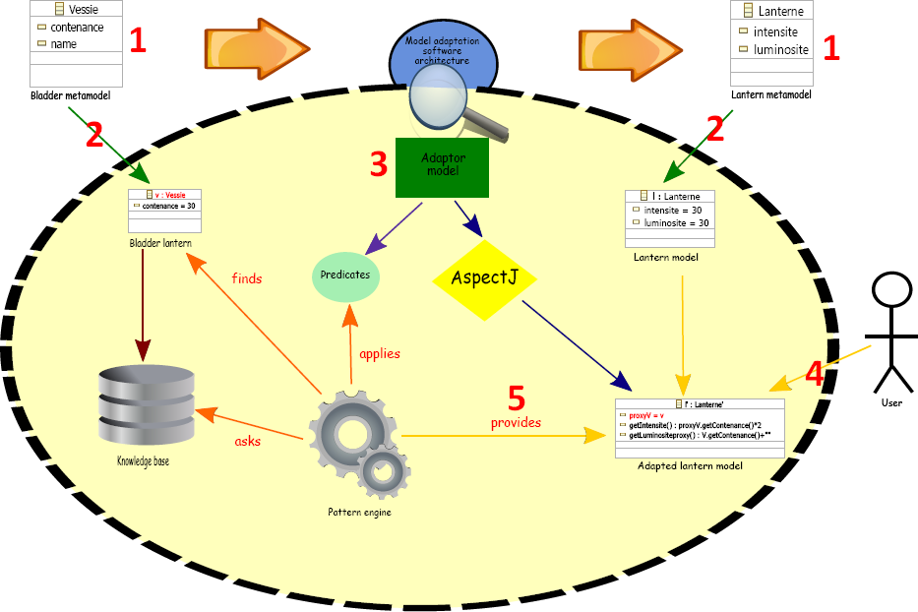

1 Mechanism schema

1: Firstly, there is the creation of the two metamodels: the one which models must be adapted and the one that is the target of the adaptation.

2: After that, the second step is the creation of the source model and eventually the target model in accordance with their respective metamodel.

3: Next you will have to define an adaptor model based on the adaptor metamodel that will tell the pattern engine how to adapt the source model into a target model element.

4: When the adaptor model is complete and all the adaptation rules described, you can run the pattern engine that will do all that is needed to make the adaptation possible.

5: Finally, the pattern engine returns an AdaptedFactory you can use in order to adapt an element of the source model.

Every operation will be further explained in details.

II Required configuration

You will need at least a minimum configuration to run the adaptor program:

Name | Version | Download address
Java Runtime Environment (JRE) | 1.5 | http://java.sun.com/javase/downloads/index.jsp
Eclipse | 3.3.2 | http://www.eclipse.org/downloads/download.php?file=/eclipse/downloads/drops/R-3.3.2-200802211800/eclipse-SDK-3.3.2-win32.zip
AspectJ ajdt | 1.5.2 | http://www.eclipse.org/ajdt/downloads/

III Necessary plug-ins

If you haven’t already installed of the required plug-ins, you will find here a list of links where you can download them. All the plug-ins must be installed in the plug-ins directory of your Eclipse installation.

Required plug-ins links list:

Name | Download address | Description
EMF (Eclipse Modeling Framework) | http://www.eclipse.org/modeling/emf/downloads/?project=emf
JET (Java Emitter Template) | http://www.eclipse.org/modeling/m2t/downloads/ | Code generation tool
AspectJ | at least ajdt_1.5.2_for_eclipse_3.3 plug-in at http://www.eclipse.org/ajdt/downloads/ | Dynamic edition of Java classes tool

IV How to adapt model

For each step of the adaptation mechanism, you will find the generic actions you will have to perform to properly run the adaptor program followed by a simple example that is the Bladder-Lantern example.

1) Defining the metamodels

a. Actions to perform

The first thing you have to do is the creation of the metamodel which models will be adapted and the metamodel which instances will be the targets of the adaptation.
In order to do that, you can use Ecore that allows defining metamodels.
If you don’t know how to create a metamodel with EMF and Ecore, you can see the documentation links below that will lead to some tutorials.

b. The Bladder-Lantern example

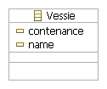
2 Bladder metamodel

This is the Bladder metamodel, which we want the models to be adapted. It contains only one EClass named Vessie with the two EAttributes:
- contenance that have EInt as EType
- name that have EString as EType

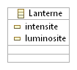
3 Lantern metamodel

This is the Lantern metamodel, which instances will be the target elements of the Bladder to Lantern adaptation. This metamodel contains one EClass named Lanterne with two EAttributes:
- intensite that have EInt as EType
- luminosite that have EString as EType

2) Generating the source models

a. Actions to perform

Now you have to generate the genmodel file corresponding to the metamodel with EMF and with the help of this genmodel, all the Java source files and projects that will allow to create models.
By executing the ProjectName.editor generated project, you will open a second Eclipse where you can instantiate your source model (that will be adapted) and eventually a target model in accordance with their metamodels.
If you don’t know how to generate a genmodel file and the metamodel associated files or how to create a model, see the EMF documentation links at the end of this manual.

b. The Bladder-Lantern example

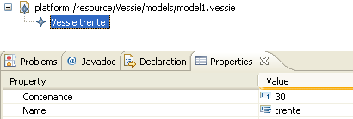

4 Bladder model

This is the bladder model, instance of the bladder metamodel. One Vessie EClass has been instanced which attributes have been initialized in the properties:
- contenance = 30
- name = “trente”

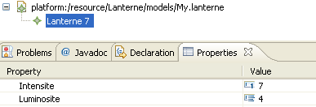

5 Lantern model

This is the lantern model, instance of the lantern metamodel. One Lanterne EClass has been instanced which attributes have been initialized in the properties:
- intensite = 7
- luminosite = 4
This model is not essential for the adaptation execution.

3) Generating the adaptor model

a. Actions to perform

You must open a second Eclipse from the adaptor.editor project in order to generate an adaptor model. This model will describe the rules according to which the adaptation will be done.
If you don’t know how to create a model, see the EMF documentation links at the end of this manual.

The model adaptor must conform itself to the adaptor metamodel that is shown in the figure below:

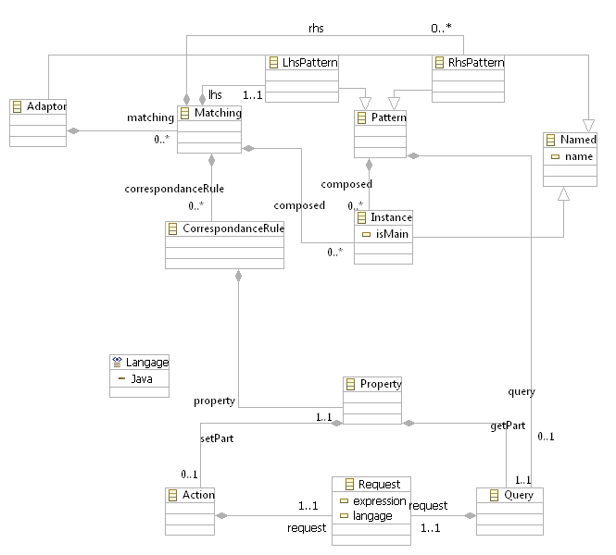

6 Adaptor metamodel

Description of the metamodel:
- Adaptor: this is the root EClass of the metamodel, it has an EString name and will contain some Matching that will describe the pattern adaptations
- Matching: this EClass structures the metamodel. It contains one LhsPattern that will be transformed into one of the RhsPattern. It also contains some CorrespondanceRule for the EAttribute adaptations
- Pattern: One Pattern is a model figure that is composed of some Instance
- LhsPattern: Extends Pattern. It corresponds to the source model patterns that will be adapted into RhsPattern.
- RhsPattern: These are the target patterns that will be instanced instead of the LhsPattern. One RhsPattern will be instanced under a condition represents by the Query EClass. The instanced RhsPattern will be the first without condition or the first which condition is correct.
  - The condition in the Java language can use the LhsPattern name as a proxy, must be a boolean expression and terminate by a semi-colon → For instance: ProxyName.getA()==20;
- Instance: It represents the instanced element of a model. The main Instance (isMain EAttribute) are LhsPattern that will become proxies in the adapted elements to the source model elements. A main Instance must have a name. Each Instance is bound to a Concept that is an EClass in the source or target metamodel.
- CorrespondanceRule: It describes the relation between the RhsPattern Instance EAttribute and the adapted LhsPattern. It contains one feature (Feature EAttribute) that is an EStructuralFeature from the target metamodel.
- Property: This is a structural EClass of the metamodel. It contains a Query that represents the getter of the CorrespondanceRule Feature and eventually an Action that will modify the setter of the CorrespondanceRule Feature.
- Action/Query: Both EClass contains a Request. The Action will modify the setter and the Query will change the getter of a feature.
- Request: The Expression EAttribute must be the entire code of the getter or setter to which the Request is bound and it must return an element which type is the same as the CorrespondanceRule Feature type.
  - If you want to use the LhsPattern Instance as proxies in the Expression, you must referred to it as “self.ProxyName”, except for the RhsPattern Query in which “ProxyName” is enough.
  - If you want to use any field from the adapted RhsPattern, you must also refer to it as “self.FieldName”.
  - You can choose the language of the Expression in the Langage EAttribute. For now, only Java is accessible.
  - For the setter, the parameter must be referred in the expression as “newValue”.
  - All the non-primitive types must be preceded by their package.
  - If the CorrespondanceRule Feature is a EReference, the getter expression must return:
    - EList if the maximal cardinality is -1
    - an object which has as type the type of the EReference feature if the maximal cardinality is 1
    - if an adaptation must be done, you have to make it (see the database-object model example for an example)

This metamodel Ecore file is located in the adaptor project in the metamodel folder.

b. The Bladder-Lantern example

Here you can see the bladder-lantern adaptor model generated from the adaptor metamodel specifications:

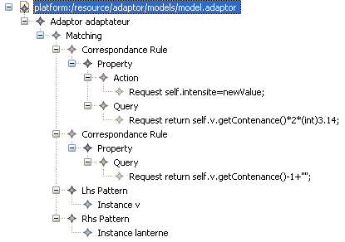

7 Bladder-lantern adaptor model

In this model, one Matching is defined that matches one Vessie v Instance of the LhsPattern with one Lanterne lanterne Instance of the only RhsPattern. The Vessie Instance will be the proxy that can be used in the adapted lanterne Instance.
There is also one CorrespondanceRule that is bound to the feature intensite of the Lanterne EClass. The setter of this feature is changed, thanks to the Action EClass, to the newValue value which is the argument of the setter. The getter of the same feature will returned an other value based on the Vessie v proxy referred as “self.v” in the “self.v.getContenance()*2*(int)3.14” Query Request expression.

4) Running the program

a. Actions to perform

The first thing you have to do is to manage the dependencies of the Blanddern project that will need some data from your source and target projects:
- the Generate all function of the source and target genmodel file must have been run in order to generate all the necessary files and project
- the project that contains the source metamodel files must be put in the dependencies of the Blanddern project. You will find these in the Required Plug-ins of the Dependencies window tab of the MANIFEST.MF file which is in the META-INF folder.
- the project that contains the target metamodel files must be put in the build path of the blanddern project if you want to instance some target EClass in the CorrespondanceRule Expressions. In order to do that, you have to right click on the Blanddern project → Build Path → Configure Build Path → Projects window tab → Click on Add button → Select your project → Click two times on OK button

To use the adaptation program, there are some instructions to execute before the adaptation itself:
- Initialize the Package of the source metamodel: “BasePackage.EcorePackage.PackageName LibraryName = BasePackage.EcorePackage.PackageName LibraryName.eInstance;”
- Launch the class that will give you the AdaptedFactory that will allow you to adapt your source model: “Launch LaunchName = new Launch(); AdaptedFactory FactoryName = LaunchName.adapt();”

When the program has been launched, a window will appear that asks you some path:

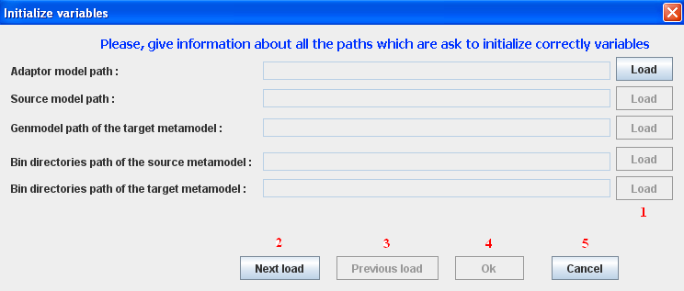

8 Paths interface

- 1: For each path, you have to select the correct file or directory by clicking on the “Load” button.
- 2, 3: If you have made a mistake, you can navigate through the different paths with the “Next load” or “Previous load” buttons.
- 4: When all the paths are completed, you can continue the execution of the program by clicking “Ok”.
- 5: If you want to cancel the program execution, you must click on the “Cancel” button or close this window, but this will make an error message appear “Paths are not correct”.

File extensions:
- Adaptor model path → .adaptor
- Source model path → .SourceMetamodelName
- Genmodel path of the target metamodel → .genmodel
- Binary directories path of the source metamodel → bin directory
- Binary directories path of the source metamodel → bin directory

From this point of the adaptation, the AdaptedFactory is being created but you have not yet adapted an element. You can see some messages that will inform you on the program execution flow:
- “Temporary directories regenerated”
- “Prolog requests generated from the adapted model”
- “Prolog program generated from the source model”
- “Lhs-pattern main-instance name of the adaptor model checked”
- “AspectJ files generated from the adaptor model”
- “AspectJ files are being executed”
- “Target metamodel implementations edited in accordance with the adaptor model”
- “Pattern filter generated from the adaptor model”
- “Adaptation factory ready to be used”
- “Source model elements are being adapted”
- “Proxies initialized”
- “Source model elements adapted”

If you see all of these messages, the program has been correctly run and you are now ready to do the adaptation.

b. The Bladder-Lantern example

9 Execution of the Blanddern project

1: First the VessiePackage of the Vessie metamodel is initialized.
2: Creation of a new instance of the Launch class that will create the AdaptedFactory.
3: The adapt() method of the Launch class is called and it returns an AdaptedFactory.

5) Adapting an element

a. Actions to perform

- In order to get your loaded source model into an EObject array, you have to use the getModel() method of the Launch class : “EObject[] ArrayName = LaunchName.getModel();”
  - The Launch class is located in the Blanddern project in the launcher source folder and in the launcher package.
- Now you can adapt an element of your source model by using the loadModel method of the AdaptedFactory class. This method takes an EObject array as argument that contains the EObjects to adapt and it returns a List that contains EObject arrays in which you will find the adapted elements. For instance : “List ListName = FactoryName.loadModel(new EObject[]{Some EObjects});”
- At this point, you can use the adapted elements of your source model as target metamodel elements.

b. The Bladder-Lantern example

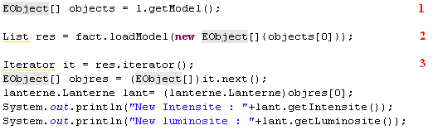

10 Adaptation execution

1 : The bladder model is loaded from the Launch class instance.
2 : The first element of the bladder is adapted into a lantern element and the result is returned inside a List.
3 : The returned List is visited and the lantern adapted element get back. This adapted element is used as a normal lantern element but with the behaviour of a bladder element thanks to the bladder proxy inside it.

The results of the getIntensite() and getLuminosite() methods are calculated according to the adaptation CorrespondanceRule and the results are:

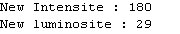

11 Bladder-lantern adaptation results

These are the correct results of the following CorrespondanceRule expressions:
- getIntensite(): “return self.v.getContenance()*2*(int)3.14”
- getLuminosite(): “return self.v.getContenance()-1+”” “
With v.getContenance()=30, where is the proxy to the adapted bladder element in the lantern element.

6) CVS Examples

If you want to test the Bladder-Lantern example or some other more sophisticated examples, you will find them on the CVS at this address: “blanddern.berlios.de”.
For each example, you will have to launch a specific class in the Blanddern project and give some files in the graphical interface:
- Bladder-Lantern example:
  - Test class : Blanddern Project → launcher Source folder → test Package → Test1.java
  - Adaptor model file : adaptor/models/model.adaptor
  - Source model file : Vessie/models/model1.vessie
  - Target metamodel genmodel file : Lanterne/metamodel/lanterne.genmodel
  - Source metamodel binary directory : Vessie/bin
  - Target metamodel binary directory : Lanterne/bin
- Complex Bladder-Lantern example:
  - Test class : Blanddern Project → launcher Source folder → test Package → Test2.java
  - Adaptor model file : adaptor/models/model2.adaptor
  - Source model file : Vessie/models/model2.vessie
  - Target metamodel genmodel file : Lanterne/metamodel/lanterne.genmodel
  - Source metamodel binary directory : Vessie/bin
  - Target metamodel binary directory : Lanterne/bin
- Database-Object model example:
  - Test class : Blanddern Project → launcher Source folder → test Package → Test3.java
  - Adaptor model file : adaptor/models/modebddobj.adaptor
  - Source model file : BdD/models/model1.bdd
  - Target metamodel genmodel file : Objet/metamodel/objet.genmodel
  - Source metamodel binary directory : BdD/bin
  - Target metamodel binary directory : Objet/bin

Feel free to use these examples to better understand the functioning of the adaptor.

V Bugs and errors

If you don’t run properly the program, you will encounter some error message and the execution will stop. Here’s the list of error message you can obtained:
- “Error during the source-model prolog transformation”
- “There can be only one map matching the EObject parameter”
  - The Matching in the adaptor model aren’t enough precisely specified.
- “AspectJ has not been able to run correctly → Incorrect model adaptor”
- “The ecore file can’t be parsed”
- “No name for ecore package”
- “Error during the creation of the adapted factory”
- “You must first run the adapt method”
- “Paths are not correct”
- “Each main instance of a lhs pattern must have a name”
- “File not found ‘FilePath’”
- “No delete path ‘Path’”
  - A directory can’t have been deleted.
- “No file path ‘Path’”
“The file FilePath has not been correctly generated”

There is one bug you can experience while executing the program that makes exception appear. If you see an unknown exception, you can refresh the Blanddern project with F5 key or the Refresh command. After that, you can normally restart the program with the same parameters.

VI Documentation links

Here’s is some links that can help you to use the needed tools for the Blanddern project:

Documentation | Web address | Section
How to create metamodels | http://www.eclipse.org/gmt/oaw/doc/4.3/openArchitectureWare-4.3-Reference.pdf | 1.1 to 1.3
How to generate genmodels | http://www.eclipse.org/gmt/oaw/doc/4.3/openArchitectureWare-4.3-Reference.pdf | 1.4
How to create models | http://www.eclipse.org/gmt/oaw/doc/4.3/openArchitectureWare-4.3-Reference.pdf | 1.5 to 1.6
How to use generated Java classes to load models | http://help.eclipse.org/help33/index.jsp?topic=/org.eclipse.emf.doc//references/overview/EMF.html | Using the Generated EMF Classes
How to use Eclipse | http://jmdoudoux.developpez.com/java/eclipse/

VII Contacts

If you meet some bugs or problems, please send us an email, with a short description of your bug.

Here are contact emails:
- Frédéric Fondement: frederic.fondement@uha.fr
- Jérémie Scheer: jeresch@gmail.com
- Loïc Sutter: loic_sutter@yahoo.fr

Table of contents :

Summary 2
I Adaptation mechanism 3
II Required configuration 4
III Necessary plug-ins 4
IV How to adapt model 5
1) Defining the metamodels 5
a. Actions to perform 5
b. The Bladder-Lantern example 5
2) Generating the source models 6
a. Actions to perform 6
b. The Bladder-Lantern example 6
3) Generating the adaptor model 7
a. Actions to perform 7
b. The Bladder-Lantern example 9
4) Running the program 9
a. Actions to perform 9
b. The Bladder-Lantern example 11
5) Adapting an element 11
a. Actions to perform 11
b. The Bladder-Lantern example 12
6) CVS Examples 13
V Bugs and errors 13
VI Documentation links 14
VII Contacts 14
Table of contents : 15
Table of illustrations : 16

Table of illustrations :

1 Mechanism schema 3
2 Bladder metamodel 5
3 Lantern metamodel 5
4 Bladder model 6
5 Lantern model 6
6 Adaptor metamodel 7
7 Bladder-lantern adaptor model 9
8 Paths interface 10
9 Execution of the Blanddern project 11
10 Adaptation execution 12
11 Bladder-lantern adaptation results 12

